Positive Behavior Support at  
 Arthur Street Elementary School

**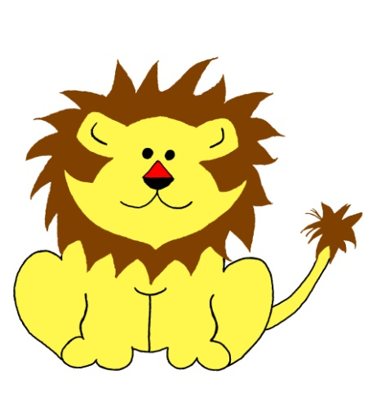**

**PRIDE produces the following outcomes:**

****A school-wide positive behavior program that teaches pride, respect, safety, and responsibility**

**PRIDE**

****Increased engaged learning time for students**

**  
Unity in our school community**

**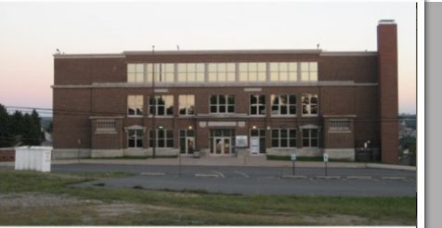**

**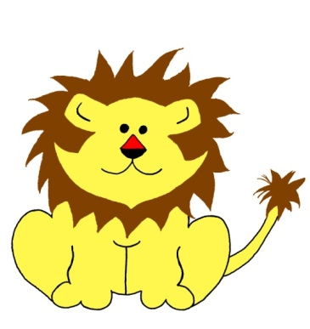**

Positive Behavior Support at  
 Arthur Street Elementary School

|  |
| --- |
| **P ROUD to be me *(Liking and Caring about yourself )***  **R ESPECT for others *(Treating others how I want to be treated )***  **I will be READY (*Having what I need, being on time )***  **D o the SAFE thing (*Free from danger, harm or injury*)**  **E veryone shows PRIDE!** |

**PRIDE IN THE CLASSROOM**

|  |
| --- |
| **I will stay in my own *space* and keep my hands and feet to myself.**  **MCj04241680000[1]**  **Space** – Any place the teacher asks me  to be at anytime during the day |
| **MCj04361610000[1]I will use kind words and tell the *truth*.**  **Truth** - What really happened or is  happening (honesty) |
| **I will respect school *property* and the *property* of others.**  MCj03981390000[1]  **Property** – Any item that belongs to  someone or belongs to the school |
| **I will complete my *school work* and my *homework*.**  **MCj02954800000[1]**  **School work** - Work done in school  **Homework** - Work assigned by the teacher for me to do at home |
| MCj03981250000[1]**I will raise my hand to *speak* and wait to be called upon.**  **Speak** - To talk |
| MCj02327600000[1]MCj03980530000[1]**I will use my *materials* *appropriately*.**  **Materials** - Any item in the classroom that I use  **Appropriately** - Correctly |

***This is a universal (school-wide) rule***

|  |
| --- |
| **I will stay in my own *space* and keep my hands and feet to myself.**  MCPE02650_0000[1]  **Space** – Any place the teacher asks the child to be at anytime during the day |
| **MCBD10653_0000[1]I will use kind words and tell the *truth*.**  **Truth** - What really happened or is happening (honesty) |
| **I will respect school *property* and the *property* of others.**  MCj03391880000[1]  **Property** – Any item that belongs to  someone or belongs to the school |
| **MCj04348080000[1]I will keep my *area* clean.**  **Area** – The place around me |
| **I will *walk* at all times.**  **Walk** – Moving slowly and not running, keeping my hands at my side |
| **I will *respect* the adults in charge.**  **Respect** – To treat others how you would want to be treated |

**PRIDE IN THE CAFETERIA**

***This is a universal (school-wide) rule***

**PRIDE IN THE HALL AND STAIRS**

|  |
| --- |
| **I will stay in my own *space* and keep my hands and feet to myself.**  MCBD07022_0000[1]  **Space** – Any place the teacher asks the child to be at anytime during the day |
| MCj04361610000[1]**I will use kind words and tell the *truth*.**  **Truth** - What really happened or is  happening (honesty)  . |
| **I will respect school *property* and the *property* of others.**  MCj03983170000[1]  **Property** - Any item that belongs to  someone or belongs to the school |
| **I will always walk in a *single file* line with my hands at my side.**  MCj03981530000[1]  **Single file** – Walking behind the person in front of me |
| MCj04378030000[1]**I will be *SILENT* in the halls.**  **Silent** – Not talking |
| **I will NOT open the outside door for *ANYONE* at ANYTIME.**  **Anyone** – Any person at all (a teacher, a parent, a student) |

***This is a universal (school-wide) rule***

**PRIDE IN THE RESTROOM**

|  |
| --- |
| **I will stay in my own *space* and keep my hands and feet to myself.**  C:\Documents and Settings\P\Local Settings\Temporary Internet Files\Content.IE5\GMZYOY1U\MCj04382310000[1].wmfC:\Documents and Settings\P\Local Settings\Temporary Internet Files\Content.IE5\9123GTGR\MCWB01074_0000[1].gif  **Space** – Any place the teacher asks the child to be at anytime during the day |
| **I will use kind words and tell the *truth*.**  **MCj04361610000[1]**  **Truth** - What really happened or is  happening (honesty) |
| **I will respect school *property* and the *property* of others.**  **MCHH01463_0000[1]**  **Property** - Any item that belongs to  someone or belongs to the school |
| **I will *wash* my hands.**  **Wash** – To clean your hands with soap and water |
| **MCj04378030000[1]I will use a *quiet* voice in the restroom.**  **Quiet** – Soft (inside voice) |

***This is a universal (school-wide) rule***

**PRIDE ON THE BUS / DISMISSAL**

|  |
| --- |
| **I will stay in my own *space* and keep my hands and feet to myself.**  MCj02921140000[1]  **Space** – Any place the teacher asks the child to be at anytime during the day |
| **I will use kind words and tell the *truth*.**  **Truth** - What really happened or is  happening (honesty) |
| **I will respect school property and the *property* of others.**  MCj03981190000[1]  **Property** - Any item that belongs to  someone or belongs to the school |
| **MCj02921140000[1]I will sit in my seat at all times.  I will *not* stand while the bus is moving.** |
| MCj03656480000[1]**I will *listen* to the *bus driver*.**  **Listen** – Obey, respect  **Bus driver** – The man or woman who drives the bus. They are in charge |
| **At *dismissal*, I will *listen quietly* for my bus to be called.**  **MCj02381920000[1]MCj04257400000[1]**  **Dismissal** – The time of day when we leave the school **Listen quietly**- Paying close attention |

***This is a universal (school-wide) rule***

**PRIDE ON THE PLAYGROUND**

|  |
| --- |
| **I will stay in my own *space* and keep my hands and feet to myself.**  MCj02911040000[1]  **Space** – Any place the teacher asks the child to be at anytime during the day |
| **I will use kind words and tell the *truth*.**  **Truth** - What really happened or is  happening (honesty) |
| **I will respect school *property* and the *property* of others.**  MCPE06595_0000[1]  **Property** - Any item that belongs to  someone or belongs to the school |
| **I will walk quietly to the playground and use the *crosswalk*.**  **Crosswalk** – The area where you cross the street (in between white lines) |
| **MCSL00636_0000[1]I will *remain* in the playground area.**  **Remain** – Stay |
| **I will NOT use the *monkey bars* or *see-saw*!**  MCj02771960000[1]MCj02772220000[1]  **Monkey Bars** – The silver metal bars that children climb  **See-saw -** teeter-totter |
| **C:\Documents and Settings\P\Local Settings\Temporary Internet Files\Content.IE5\C163G1E3\MCj04360430000[1].wmfI will play *fairly* and *include* others in the game!**  **Fairly** – Following the rules  **Include**- Let others play |

***This is a universal (school-wide) rule***

**MCj04260820000[1]**

**School-Wide Reinforcement Plan**

******

**Students can a token or paw punch from staff members in the building**

**by modeling expected positive behaviors.**

**Cards can be redeemed through classroom store.**

**Classes earn PRIDE PAW from staff members when caught**

**modeling expected positive behaviors.**

**Entire school celebrates as classes reach behavior goals.**

***Everyone shows PRIDE***



**Parents’ Role in PRIDE**

****

**Parents know their child’s specific grade level behavior expectations.**

****

**Parents sign the PRIDE contract, thereby agreeing to support their child in**

**meeting behavior expectations.**

**Parents model and reinforce pride, respect, safety, and responsibility at**

**home.**

****

**Parents participate in celebrating the positive behavior success of their**

**child.**